Brenden Brown

Prof. Evans

HSA 10

7 March 2016

**The Volatility of Uranium Prices and its Effect on the Future of Nuclear Power**

Nuclear power was first given consideration in 1945, following the development of the atomic bomb. Scientists figured that if they could get radioactive elements to release enough energy to power cities, they could use those same radioactive elements to produce energy for naval propulsion. After 1956, the focus of nuclear power turned to creating reliable nuclear power plants.

Nuclear reactors are very complicated and their designs vary slightly, but the basic premise of a nuclear reactor is that radioactive elements undergo fission to heat up water to turn turbines and produce electricity. This process can be better visualized in figure 1.

Figure 1. How nuclear power plants work.

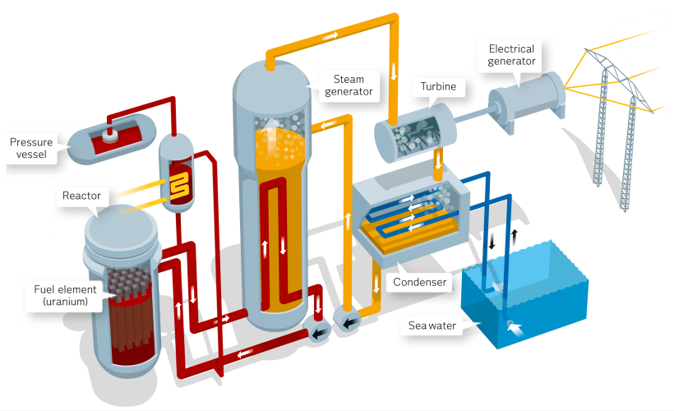

But what radioactive element(s) fuels these nuclear reactors? As of now there are two sources of radioactive material used in nuclear power plants – Uranium and Thorium. However, since Uranium use far outweighs Thorium use as of now, we will be focusing on Uranium and how it pertains to nuclear power for the rest of this paper.

Uranium (chemical symbol U) was discovered by a German chemist, Martin Klaproth in 1789. It is a heavy element (18.7 times as dense as water) that is very abundant in nature. However, what makes Uranium special is its isotope, Uranium 235 (U-235), which, under certain conditions can be readily split and release a large amount of energy.

Uranium, much like oil and coal, has a specific market for which it is sold. However, as we will see, the Uranium market is much more volatile than others like coal and oil. I believe this volatility will play a great roll in the use of nuclear power in the future. But, before we can come to these conclusions we must gain and understand of the Uranium market as well as knowledge on the advantages and disadvantages of nuclear power.

First we need to understand the advantages and disadvantages of nuclear power so we can understand why nuclear power is used, and therefore why we care about the price market of Uranium. To begin, nuclear power has very little pollution. When functioning properly, nuclear power has no harmful impact to the environment around it with the exception of the times when uranium or water must be transported to the nuclear power plant. The next major advantage of nuclear power is that it produces a large amount of energy for essentially only the price of the Uranium used in the plant. This is the main reason we care about the volatility of the Uranium price market. Nuclear power plants virtually have no constraints on where it can operate. Other energy sources such as wind, solar or hydro energy resources require specific environments to operate. In addition to this, nuclear power plants require little attention when functioning properly, being able to produce energy for up to a year before needing new Uranium. Finally, nuclear power is an almost unlimited source of power. Based on the amount of Uranium needed to fuel a reactor and the abundance of Uranium in the Earth, there will be plenty of nuclear energy to go around.

Nuclear energy, on the other hand, does have some disadvantages that we must take into consideration. To start, nuclear energy has a large environmental impact which stems mainly from how we obtain the Uranium used for reactors, how we transport Uranium, as well as the disposal of Uranium once it is used up. Again, we can see why we care so much about the price of Uranium. If we have to pay a high price for Uranium and a high price to clean it up, it may not be worth buying.

The next problem with nuclear power is a continuation of the environmental problems with using nuclear energy. The waste produced by nuclear reactors is highly radioactive and very hot. It will eat through anything that holds it. So, as of now, we just bury the waste underground and wait for it to decay.

Nuclear energies biggest con is the scare of the nuclear accident. Everyone always hears about the times when nuclear power plants don’t function properly and “meltdown”, causing extreme damage to the area and, in turn, causing a large amount of money to be put into cleaning up the waste.

Now that we see the some of the major advantages and disadvantages of nuclear power, we can adequately examine the price market for Uranium and come to a conclusion about how this price market will affect the future of nuclear power.

To begin we will look at the relationship between the production and price relationship of Uranium over the past 50 years. (See figure 2).

Figure 2. Price-production relationship for Uranium.

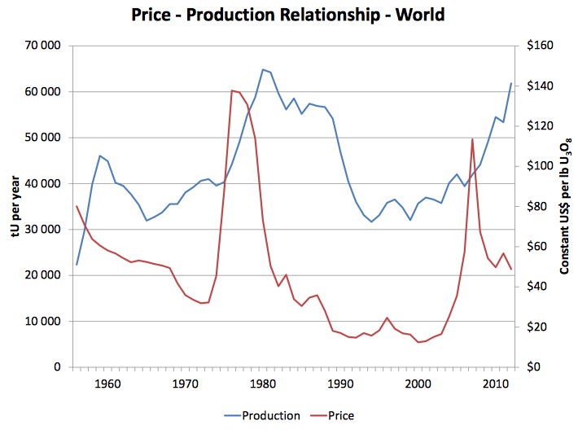

As we can see nuclear prices began to decline in the 60s to the early 70s. However for a short period in the 70s, Uranium prices matched the slope of the increasing production of uranium to go along with the exponential growth of nuclear power in the world.

In the late 70s, on the other hand, the price of Uranium went down significantly and continued like that until around 2002. This period was called the nuclear power brown-out, in which nuclear power plant development started to halt and few nuclear reactors were being built as well as many reactors being shut down. This has been the main cause of the volatility of the Uranium price market. Because nuclear power became less popular, but Uranium became more available, the Uranium price market saw a decline in price very similar to that of oil. But, unlike the oil market, the Uranium market cut production to go along with the price decline. If we look at figure 2, we can see that for the most part, the price market of Uranium, while unstable has essentially matched the production (i.e. the supply) of Uranium. That is, until the past decade. In the past decade, Uranium production has peaked yet the price of Uranium has been steadily decreasing to prices lower than those of the 60s. This is what has made the Uranium price market so volatile in recent years. Nobody has a real idea of what the Uranium prices will do. Even though nuclear power is more popular than it has been, it is still currently in the shadow of other “green” energy sources. This popularity of other energy sources will likely steady out the demand of Uranium and will keep the price of Uranium trending downward.

But how do we determine how this will affect the future of nuclear power? To answer this we will first look at the amount of Uranium that has been demanded over the past 50 years. (See figure 3)

Figure 3. Historical World Uranium requirements.

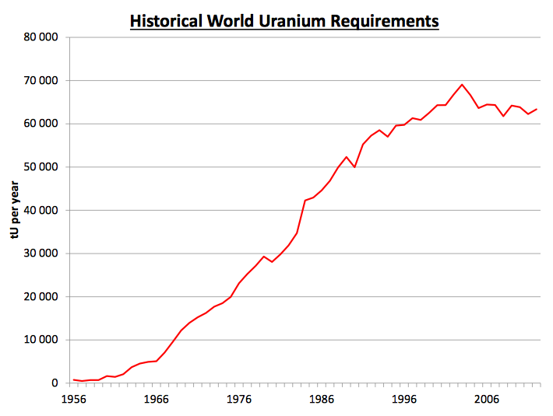

Clearly, for the 20th century the demand for Uranium was exponentially increasing, but in recent years has come to a halt, meaning nuclear power plant production has come to a halt. But why has this happened? If we look at the Uranium price market (see figure 2) it seems that Uranium prices have steadily dropped in the past decade.

To me, this indicates that although the volatility of Uranium prices is very interesting, it is not the reason why nuclear energy is not continuing to grow exponentially. Nuclear energy has been looked at more heavily for its disadvantages in recent years and, along with the advertising of solar and wind energy, has been put on the back burner of people’s minds. In fact, predictions show a decline in nuclear energy use in future years as shown in figure 4.

Figure 4. World electricity predictions to the year 2040.

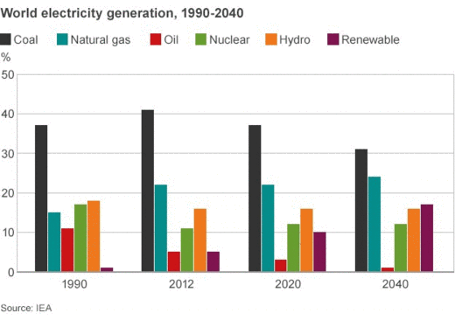

In my opinion, despite the predictions, we must reconsider the advantages of nuclear, solar and wind energy before deciding where to invest our resources for the future. Nuclear energy seems so promising if we can get over our fear of meltdowns and reservations on disposal. If we do, we may see that the decline in price of Uranium may make nuclear power a cheaper, more reliable, and more productive source of energy to fuel our world.

Works Cited

Adeyanju, Craig. "The Top Factors That Move the Price of Uranium." *The Top Factors That Move the Price of Uranium*. N.p., 13 Aug. 2014. Web. 06 Mar. 2016.

Anderson, Richard. "Nuclear Power: Energy for the Future or Relic of the Past? - BBC News."*BBC News*. BBC News, 27 Feb. 2015. Web. 06 Mar. 2016.

Johnson, Keith. "What's Holding Back Nuclear Energy." *WSJ*. Wall Street Journal, 11 Nov. 2013. Web. 06 Mar. 2016.

"Nuclear Power - How It Works." *Vattenfall*. N.p., n.d. Web. 06 Mar. 2016.

"Outline History of Nuclear Power." *History of Nuclear Energy*. World Nuclear Association, n.d. Web. 06 Mar. 2016.

"Pros and Cons of Nuclear Energy - Conserve Energy Future."*ConserveEnergyFuture*. N.p., 06 Mar. 2015. Web. 07 Mar. 2016.

"Supply of Uranium." *Uranium Supplies: Supply of Uranium*. N.p., n.d. Web. 06 Mar. 2016.

"Uranium Markets." *Uranium Markets: World Nuclear Association*. N.p., n.d. Web. 06 Mar. 2016.

"Uranium Prices." *Denison Mines Corp.* N.p., n.d. Web. 06 Mar. 2016.

"What Is Uranium? How Does It Work?" *What Is Uranium? How Does It Work*. N.p., n.d. Web. 06 Mar. 2016.